Bangladesh Medical Association (BMA)
List of Life Member-91
31. BMA Kurigram Branch

Sl No | Voter No | Voter Details
1 | Voter No  LM-3100001  No Image | DR. MD. SHAHADAT HOSSAIN  F/Name: Late Safar Uddin  M/Name:  BM & DC Reg. No:  NID:  Cell:  Address: Thana Health & F.P.O  Nageshwari  Kurigram  Blood Group:
2 | Voter No  LM-3100002 | DR. MD. MOUDUD HOSSAIN  F/Name: Late Abdul Quayum Sarkar  M/Name:  BM & DC Reg. No:  NID:  Cell:  Address: Sheba Clinic  Kurigram  Blood Group:
3 | Voter No  LM-3100003  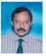 | DR. MD. MAHFUZAR RAHMAN  F/Name: Ahmed Hossain  M/Name:  BM & DC Reg. No:  NID:  Cell:  Address: Old Station Para  Kurigram  Blood Group:
4 | Voter No  LM-3100004  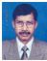 | DR. MRINAL KANTI ROY  F/Name: Mr. Basanta Kumar Roy  M/Name:  BM & DC Reg. No:  NID:  Cell:  Address: Surgical Specialist  Ghosh Para  Kurigram  Blood Group:
5 | Voter No  LM-3100005 | DR. S.M. AMINUL ISLAM  F/Name: Sk. Ahmed Hossain  M/Name:  BM & DC Reg. No:  NID:  Cell:  Address: Medical Officer  Sadar Hospital  Kurigram  Blood Group:
6 | Voter No  LM-3100006  No Image | DR. MD. TAIBUR RAHMAN  F/Name:  M/Name:  BM & DC Reg. No:  NID:  Cell:  Address: TRANSFERED to BMA Dinajpur Br.  Blood Group:  TRANSFERED to BMA Dhaka City  LM-1405543
7 | Voter No  LM-3100007  No Image | DR. MD. KHALID HASAN  F/Name:  M/Name:  BM & DC Reg. No:  NID:  Cell:  Address: TRANSFERED to BMA Dinajpur Br.  Blood Group:  TRANSFERED to BMA Dhaka City  LM-1405543
8 | Voter No  LM-3100008 | DR. SUDIP KUMAR BOSE  F/Name: Late Binoy Kumar Bose  M/Name:  BM & DC Reg. No:  NID:  Cell:  Address: Voter No  LM-3100008  Dr. Sudip Kumar Bose  F/Name: Late Binoy Kumar Bose  Nazimkhan  Rajarhat  Kurigram  Blood Group:
9 | Voter No  LM-3100009 | DR. MD. GOLAM MOSTOFA  F/Name:  M/Name:  BM & DC Reg. No:  NID:  Cell:  Address: Thana Health & F.P.O  Bhurungamari  Kurigram  Blood Group:
10 | Voter No  LM-3100010 | DR. MD. ABUL KALAM AZAD  F/Name: Late Abdus Sattar  M/Name:  BM & DC Reg. No:  NID:  Cell:  Address: Civil Surgeon Office  Kurigram  Blood Group:
11 | Voter No  LM-3100011  No Image | DR. SHAMSUDDIN AHAMAD  F/Name: Janab Sekandar Ali  M/Name:  BM & DC Reg. No:  NID:  Cell:  Address: Asst. Director  DGHS  Dhaka  Blood Group:
12 | Voter No  LM-3100012  No Image | DR. MD. MAHBUBUL ALAM  F/Name: Late Bashiruddin Ahmed  M/Name:  BM & DC Reg. No:  NID:  Cell:  Address: Thana Health & F.P.O  Ulipur. Kurigram.  Blood Group:
13 | Voter No  LM-3100013  No Image | DR. MD. RAFIQUL ISLAM  F/Name:  M/Name:  BM & DC Reg. No:  NID:  Cell:  Address: Officer, Thana Health Complex,  Chilmari, Kurigram.  Blood Group:  TRANSFERED to BMA Dhaka City  LM-1405543
14 | Voter No  LM-3100014 | DR. MD. NURUL ISLAM  F/Name: Late Abdur Rahman  M/Name:  BM & DC Reg. No:  NID:  Cell:  Address: Thana Health & F.P.O  Rowmari  Kurigram  Blood Group:
15 | Voter No  LM-3100015 | DR. MD. MOKSED ALI  F/Name:  M/Name:  BM & DC Reg. No:  NID:  Cell:  Address: Thana Health & F.P.O  Ulipur  Kurigram  Blood Group:
16 | Voter No  LM-3100016  No Image | DR. MD. ALAUDDIN AL AZAD  F/Name:  M/Name:  BM & DC Reg. No:  NID:  Cell:  Address: Junior Consultant Ortho. Sur.  Sadar Hospital,Kurigram  Blood Group: A+  TRANSFERED to BMA Dhaka City  LM-1405543
17 | Voter No  LM-3100017 | DR. MD. MUNJUR RAHMAN  F/Name:  M/Name:  BM & DC Reg. No:  NID:  Cell:  Address: Medical officer, MCH  Fulbari  Kurigram  Blood Group:
18 | Voter No  LM-3100018  No Image | DR. YEASMIN ARA HAQUE CHOWDHURY  F/Name:  M/Name:  BM & DC Reg. No:  NID:  Cell:  Address: Medical Officrer Clinic M.C.W.C Kurigram.  Blood Group:
19 | Voter No  LM-3100019 | DR. G.H.M SHAHIDUL HAQUE  F/Name: Md. Abdul Ghani  M/Name:  BM & DC Reg. No:  NID:  Cell:  Address: Junior Consultant ENT.  Sadar Hospital  Kurigram  Blood Group:
20 | Voter No  LM-3100020 | DR. A.T. M ANOWARUL HAQUE PRAMANIK  F/Name: Md. Altaf Hossain Pramanik  M/Name:  BM & DC Reg. No:  NID:  Cell:  Address: Junior Consultant (Pediatrics)  Sadar Hospital, Kurigram  Blood Group:
21 | Voter No  LM-3100021  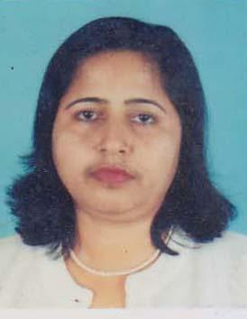 | DR. NASREEN BEGUM  F/Name: Late Abdul Haque Talukder  M/Name: Late Razia Shamsun Nahar  BM & DC Reg. No: 14244  NID: 4925205129789  Cell: 01712206663  Address: M.O (CC) District Family Planning Office, Kurigram  Blood Group: B+
22 | Voter No  LM-3100022 | DR. MD.SHAHIDULLAH  F/Name: Alhaj Taslimuddin Ahmed  M/Name:  BM & DC Reg. No:  NID:  Cell:  Address: Vill:Gostijpara  Thana:+Post:Kurigram  Blood Group:
23 | Voter No  LM-3100023 | DR. MD. MOKHLESUR RAHMAN SARKER  F/Name: Md. Akbor Ali Sarker  M/Name: Mst. Maleka Begum  BM & DC Reg. No: 22292  NID: 8524904042148  Cell: 01712014363  Address: 6/E, Doctor\'s Quarter, 2nd Floor (east), Rangpur Medical College Campus, Rangpur  Blood Group: AB_po
24 | Voter No  LM-3100024  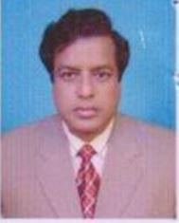 | DR. MD. MAHAFUZER RAHMAN SARKER  F/Name: Mohammad Ali Sarker  M/Name: Mrs. Mozida Begum  BM & DC Reg. No: 21042  NID: 4925203110821  Cell: 01712212065  Address: Medicla Officer, Rajibpur Health Complex, Kurigram  Blood Group: O+
25 | Voter No  LM-3100025 | DR. AJAY KUMAR ROY  F/Name: Nimai Chandr Roy  M/Name:  BM & DC Reg. No:  NID:  Cell:  Address: Resident Medical Officer,  Sadar Hospital Kurigram  Blood Group:
26 | Voter No  LM-3100026 | DR. AMIT KUMAR BOSE  F/Name: Late Anukul Ch. Bose  M/Name: Mrs. Basanti Bose  BM & DC Reg. No: 16352  NID:  Cell:  Address: Upazilla Health Complex, Kachua, Bagerhat  Blood Group: A+
27 | Voter No  LM-3100027 | DR. MD. TAZUL ISLAM  F/Name: Late Rofiqul Haque Mondol  M/Name: Late Jaida Khatoon  BM & DC Reg. No: 12288  NID: 4925205120671  Cell: 01718319215  Address: Gostipara, Post+Thana+Dist:Kurigram  Blood Group: O+
28 | Voter No  LM-3100028  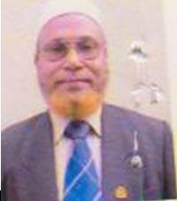 | DR. MD. NASIR UDDIN  F/Name: Late. Kanchan Mahmud  M/Name: Late. Nasimon Bibi  BM & DC Reg. No: 6498  NID: 4925208136136  Cell: 01819663835  Address: Vocational More, Krishnapur, P.O.+Dist.- Kurigram  Blood Group: B+
29 | Voter No  LM-3100029  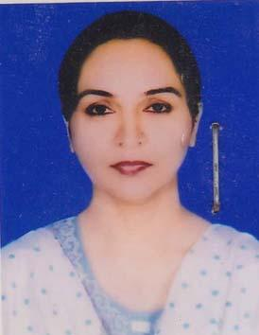 | DR. NARGIS PARVIN  F/Name: Late Mosharaf Hossain  M/Name: Mrs. Rowshanara Begum  BM & DC Reg. No: 27185  NID: 2694814935205  Cell: 01712194842  Address: 10/17, Iqbal Road, Mohammadpur, Dhaka-1207  Blood Group: O+
30 | Voter No  LM-3100030  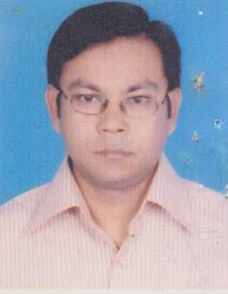 | DR. A.N.M. GOLAM MOHAIMEN  F/Name: Dr. Md. Nasir Uddin  M/Name: Mrs. Mozida Begum  BM & DC Reg. No: 42254  NID: 19794925208000003  Cell: 01717001631  Address: UHC, Ulipur, Kurigram  Blood Group: B+
31 | Voter No  LM-3100031  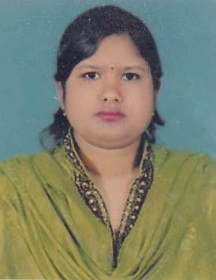 | DR. MOST. NASIMA KHATUN  F/Name: Md. Amir Hossain  M/Name: Umme Kulsum  BM & DC Reg. No: 37519  NID: 8524904052518  Cell: 01716408986  Address: Al- Nasir General Hospital, Vocational More, Krishnopur, Sadar, Kurigram  Blood Group: O+
32 | Voter No  LM-3100032 | DR. MD. SHAHIDUL ALAM  F/Name: Late Alef Uddin Ahmed  M/Name: Late Rahima Begum  BM & DC Reg. No: 17670  NID: 2694814442462  Cell: 01819127402  Address: Vill: Nazira, Post: Khalilganj, Thana+Dist: Kurigram  Blood Group: B+
33 | Voter No  LM-3100033  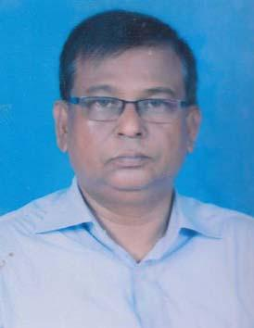 | DR. LOKMAN HAKIM  F/Name: Late Abdul Malek  M/Name: Mrs. Asiya Khatun  BM & DC Reg. No: 15279  NID: 4929405588521  Cell: 01556478907  Address: Deputy Civil Surgeon, Kurigram  Blood Group: B+
34 | Voter No  LM-3100034  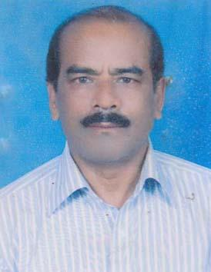 | DR. MD. TAUFIQUL ISLAM  F/Name: Late Saidul Hossain Khandoker  M/Name: Most. Golzan Begam  BM & DC Reg. No: 7459  NID: 5215520261469  Cell: 01712263359  Address: 87/1 Islam Bag, Sarak. Rangpur.  Blood Group: O+
35 | Voter No  LM-3100035  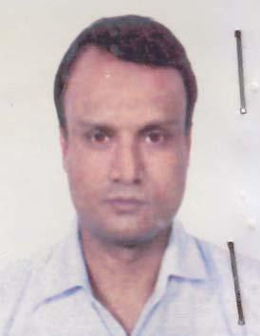 | DR. MD. SHAFIQUL ISLAM  F/Name: Md. Abdul Jabber  M/Name: Mrs. Sufia Begum  BM & DC Reg. No: 33905  NID: 4925207133931  Cell: 01718-771829  Address: House-292, Road-02, Baitul Aman Housing Shamoli, Dhaka  Blood Group: AB_po
36 | Voter No  LM-3100036  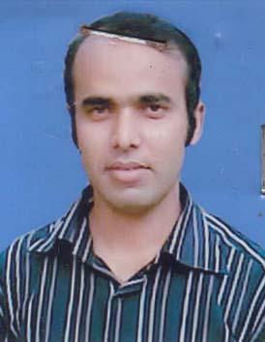 | DR. MD. HABIBUR RAHMAN  F/Name: Late. Abdul Hakim  M/Name: Late. Habiba Khatun  BM & DC Reg. No: 35639  NID: 4929407597628  Cell: 01191435391  Address: Thesis Part Student, Dept. Of Neurosurgery BSMMU, Shahbag, Dhaka  Blood Group: A+
37 | Voter No  LM-3100037  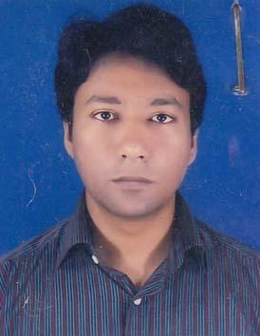 | DR. SIDHARTHA SHANKER BOSE  F/Name: Dr. Sudip Kumar Bose  M/Name: Mrs. Rita Sarker  BM & DC Reg. No: 56256  NID: 2617272869490  Cell: 01717098925  Address: C/O Dr. Sudip Kumar Bose, Post- Nazimkhan, Vill- Monarkuthi, P.S- Rajarhat, Dist- Kurigram  Blood Group: O+
38 | Voter No  LM-3100038  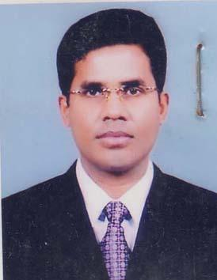 | DR. S.M. NURUN NABI  F/Name:  M/Name:  BM & DC Reg. No: 31238  NID: 4910613426398  Cell: 01714333403  Address: Asst. Registrar Dept. of Paediatrics, Rangpur Medical College Hospital, Rangpur  Blood Group: AB_po  TRANSFERED to BMA Dhaka City  LM-1405543
39 | Voter No  LM-3100039  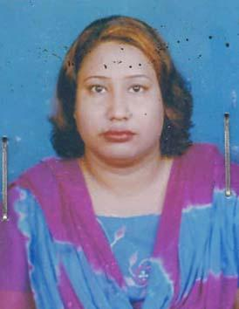 | DR. MARUFA AKHTER JAHAN  F/Name: Md. Mostafizur Rahman  M/Name: Mrs. Monoara Begum  BM & DC Reg. No: 33929  NID: 7323602607598  Cell: 01737171421  Address: MO (Clinic), MCWC, Kurigram  Blood Group: B+
40 | Voter No  LM-3100040  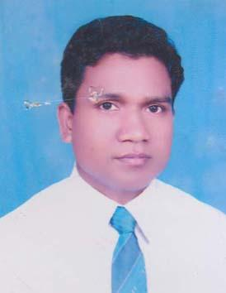 | DR. MD. ALAMGIR HOSSAIN  F/Name: Md. Nazrul Islam  M/Name: Ms. Nurjahan Begum  BM & DC Reg. No: 38684  NID: 2627209608464  Cell: 01726058081  Address: Medical Officer, Kurigram Diabetic Hospital, Kurigram  Blood Group: A+
41 | Voter No  LM-3100041  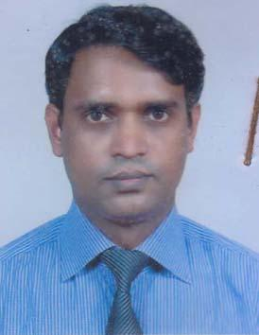 | DR. MD. NAZRUL ISLAM  F/Name: Md. Shahjahan Sarker  M/Name: Mrs. Jahanara Begum  BM & DC Reg. No: 30378  NID: 4911840078607  Cell: 01710868407  Address: Doctor\'s Quatre, Sadar Hospital, Kurigram  Blood Group: AB_po
42 | Voter No  LM-3100042 | DR. NAZRUL ISLAM  F/Name: Md. Ibrahim Ali  M/Name: Mst. Noorjahan Begom  BM & DC Reg. No: 19298  NID: 4925204113201  Cell: 01714004225  Address: Medical Officer, M.C.H-FP, M.C.W.C Sadar Kurigram  Blood Group: A+
43 | Voter No  LM-3100043 | DR. MD. MOKHTAR ALI  F/Name: Late Bashir Uddin  M/Name: Miss. Nurjahan Begum  BM & DC Reg. No: 16904  NID: 4925209142788  Cell: 01718909975  Address: Sadar Hospital Kurigram  Blood Group: A+
44 | Voter No  LM-3100044  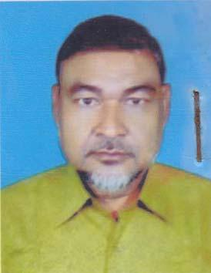 | DR. MD. SHAMSUDDOHA  F/Name: Late Serajul Haque  M/Name: Mrs. Saher Banu  BM & DC Reg. No: 10460  NID:  Cell: 01719858666  Address: Th &Fpo, Kurigram  Blood Group: B+
45 | Voter No  LM-3100045  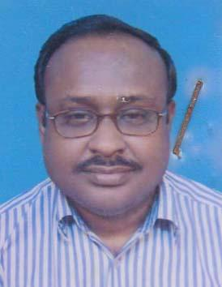 | DR. KRISHNA KUMAR PAUL  F/Name: Late Kala Chand Paul  M/Name: Sabitri Bala Paul  BM & DC Reg. No: 20139  NID: 5215505122545  Cell: 01712140745  Address: Th & FPO, Upazilla Health Complex, Fulbari, Kurigram  Blood Group: O+
46 | Voter No  LM-3100046  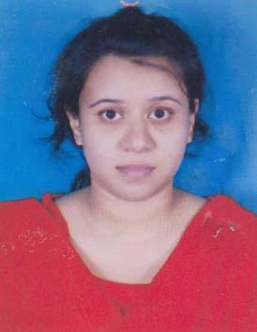 | DR. TASNIMA SULTANA  F/Name: Dr. Md. Tazul Islam  M/Name: Raojat Sultana  BM & DC Reg. No: 55390  NID: 19864925205123471  Cell: 01750110075  Address: Sultana Monjil, Hospital Road, Kurigram  Blood Group: A+
47 | Voter No  LM-3100047  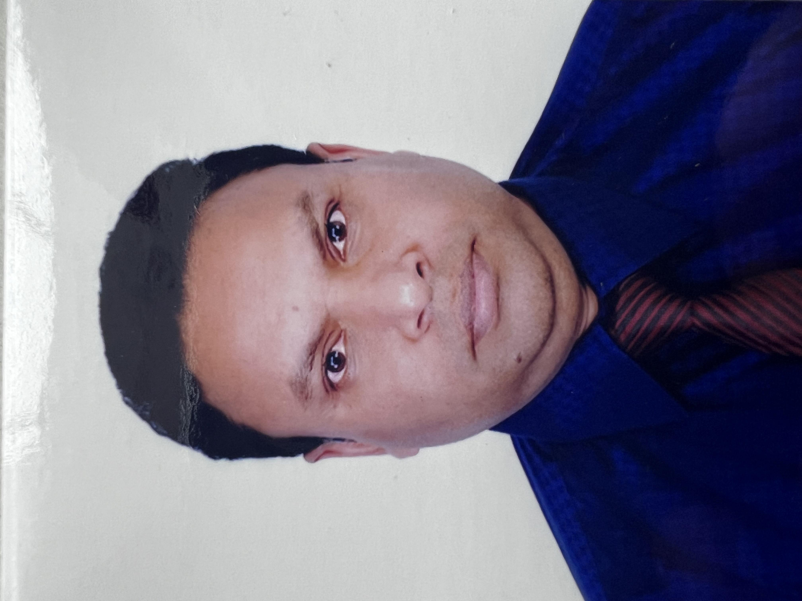 | DR. MD. ANWAR HOSSAIN  F/Name: Md. Abul Hossain Sarker  M/Name: Mrs. Zulekha Begum  BM & DC Reg. No: 28485  NID: 4919450685697  Cell: 01712238165  Address: R.K road,Islambag Rangpur  Blood Group: A+
48 | Voter No  LM-3100048  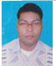 | DR. MD. MIR HOSSEN  F/Name: Md. Nur Anwar Hossen  M/Name: Most Moslema Khatun  BM & DC Reg. No: A-40607  NID:  Cell:  Address: Ghosh Para  Kurigram  Blood Group:
49 | Voter No  LM-3100049  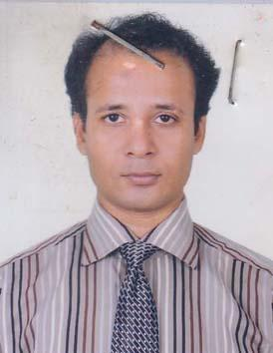 | DR. MD. ABDUS SAMAD  F/Name: Md. Mojaffar Ali  M/Name: Mrs. Shukhi Begum  BM & DC Reg. No: 38250  NID: 2696352109087  Cell: 01712967484  Address: 2/40, Razia Sultana Road, Mohammadpur, Dhaka-1207  Blood Group: A+
50 | Voter No  LM-3100050  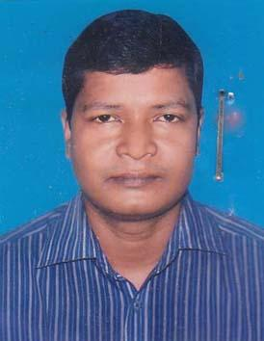 | DR. SUBHAS CHANDRA SARKAR  F/Name: Harshadu Chandra Sarkar  M/Name: Jayenty Rani Sarkar  BM & DC Reg. No: 33123  NID: 4911854026793  Cell: 01712277336  Address: Upzilla Health Complex, Ulipur, Kurigram  Blood Group: B+
51 | Voter No  LM-3100051  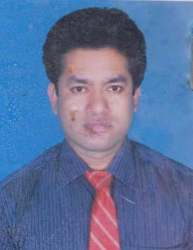 | DR. MD. RABIUL ISLAM  F/Name: Md. Ruhul Amin Sarker  M/Name: Most. Mahmuda Begum  BM & DC Reg. No: 46647  NID: 4917752976457  Cell: 01719464148  Address: 7/15, Block-C, Tajmahal Road, Mohammadpur, Dhaka  Blood Group: B+
52 | Voter No  LM-3100052  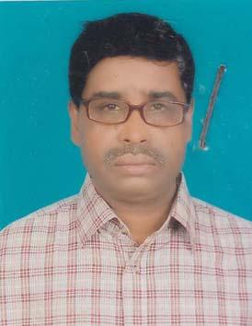 | DR. MD. OMAR ALI SARKER  F/Name: Md. Mofiz Uddin Sarker  M/Name: Most. Osimon Nesa  BM & DC Reg. No: 11851  NID: 4929406592557  Cell: 01712159305  Address: Dg Health, Dhaka.  Blood Group: A+
53 | Voter No  LM-3100053  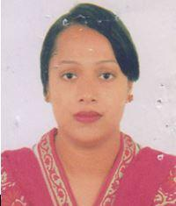 | DR. MOST. ROKEYA SULTANA  F/Name: Md. Abdul Karim Sarker  M/Name: Most. Momena Khatun  BM & DC Reg. No: 34284  NID: 2691649120442  Cell: 01716208946  Address: House no# 327/3, Road no# 8/A (New), Dhaka-1209, West. Dhanmondi  Blood Group: O+
54 | Voter No  LM-3100054  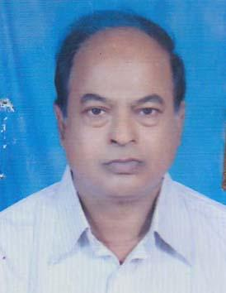 | DR. MD. AFTER ALI  F/Name: Late Fazal Uddin  M/Name: Amena Begum  BM & DC Reg. No: 13343  NID: 4915217187653  Cell: 01716671614  Address: Vill- Kaloy, P.O-Khalilgonj, PS+Dt- Kurigram  Blood Group: B+
55 | Voter No  LM-3100055  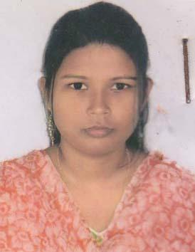 | DR. LUTFUNNAHAR  F/Name: Dr. Lokman Hakim  M/Name: Mrs. Halima Khatun  BM & DC Reg. No: 50344  NID: 4929405588943  Cell: 01671907383  Address: Vill: Ulipur, Post: Ulipur, Upazill: Ulipur, Dist: Kurigram  Blood Group: B+
56 | Voter No  LM-3100056  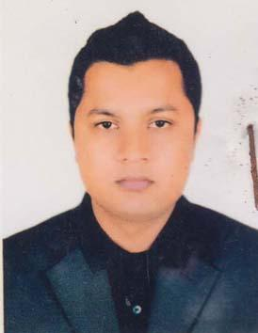 | DR. G M ARIFUR RAHMAN  F/Name: Md. Anisur Rahman  M/Name: Mrs. Fatema Pervin  BM & DC Reg. No: 63045  NID: 4925205120739  Cell: 01717441879  Address: Shapla Chattor, Kurigram  Blood Group: A+
57 | Voter No  LM-3100057  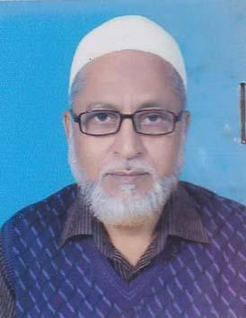 | DR. MD. ANISUR RAHMAN  F/Name: Late Khandker Abdur Rahman  M/Name: Late- Asia Khatun  BM & DC Reg. No: 9023  NID: 4925203114349  Cell: 01712759894  Address: Shapla Chattor, Kurigram  Blood Group: O+
58 | Voter No  LM-3100058  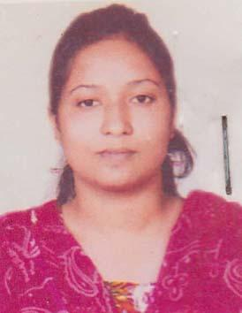 | DR. SHAMANTA SHEFIN REEMA  F/Name: Md. Mostafizur Rahman  M/Name: Mrs. Anjuma Rahman  BM & DC Reg. No: 54667  NID: 4925207132380  Cell: 01675241841  Address: Shapla Chattor, Kurigram  Blood Group: B+
59 | Voter No  LM-3100059  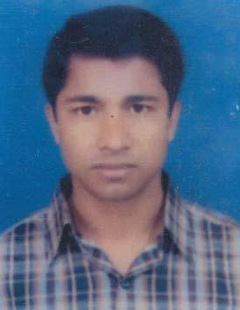 | DR. MD. SHAHNUR ALAM SARKER  F/Name: Md. Azizul Haque Sarker  M/Name: Mrs. Sufia Khatur  BM & DC Reg. No: 38721  NID: 4917742865151  Cell: 01716107142  Address: Sadar Hospital Kurigram  Blood Group: A+
60 | Voter No  LM-3100060  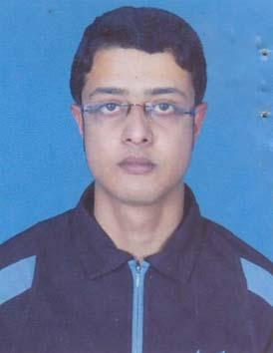 | DR. SHAKTI SHANKAR CHAKRABORTY  F/Name: Uday Shankar Chakraborty  M/Name: Shipra Rani Chakraborty  BM & DC Reg. No: 60113  NID: 4925205108316  Cell: 01727451875  Address: Shipra Rani Chakraborty Hatirpara, Kurigram  Blood Group: O+
61 | Voter No  LM-3100061  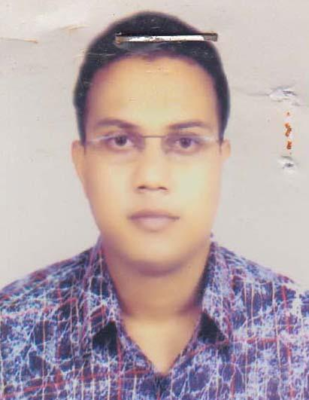 | DR. MD. SHAHINUR RAHMAN SARDER  F/Name: Md. Azizur Rahman Sarder  M/Name: Mrs. Samsun Nahar Begum  BM & DC Reg. No: 48736  NID:  Cell: 01717623160  Address: Vill: Palasbari, Post: Khalilgonj, Upazilla & Dist: Kurigram  Blood Group: B+
62 | Voter No  LM-3100062 | DR. TOWHIDA BEGUM  F/Name: Md. Delwar Hossain  M/Name: Marium Begum  BM & DC Reg. No: 52211  NID: 2924709173608  Cell: 01726488484  Address: Rahmot-A-Monzil, Nazira, Miapara, Kurigram  Blood Group: O+
63 | Voter No  LM-3100063  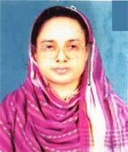 | DR. REZINA BEGUM  F/Name: Late Rahan Uddin Mollah  M/Name: Late Sayra Khatun  BM & DC Reg. No: 15670  NID: 4925205123190  Cell: 01819685135  Address: Hatirpar, Hospital para, Kurigram  Blood Group: B+
64 | Voter No  LM-3100064 | DR. G. R. M MOKSEDUR RAHMAN  F/Name: Late Habibar Rahman  M/Name: Late Moslema Khatun  BM & DC Reg. No: 17867  NID: 4926104298982  Cell: 01712969259  Address: UH & FPO, Upazilla Health Complex, Nageswari, Kurigram  Blood Group: B+
65 | Voter No  LM-3100065 | DR. RAFEZA BEGUM KAKOLY  F/Name: Late Qedur Razzak  M/Name: Khodeja Begum  BM & DC Reg. No: 25621  NID: 2610413935182  Cell: 01711844318  Address: Sobuj para, Post+Thana-Kurigram, Dist-Kurigram  Blood Group: O+
66 | Voter No  LM-3100066  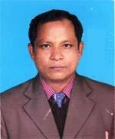 | DR. NIRMALENDU ROY  F/Name: Late Nagendra Nath Sarker  M/Name: Kaminee Bala Roy  BM & DC Reg. No: 27763  NID: 4926101289352  Cell: 01711074348  Address: Upazilla Health Complex, Bhurunamari, Kurigram  Blood Group: A+
67 | Voter No  LM-3100067  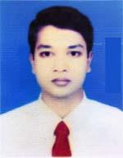 | DR. ABU SAZZAD MOHMMAD SAYEM  F/Name: Md. Jahir Uddin Sarker  M/Name: Most. Samiron Nesa  BM & DC Reg. No: 40336  NID: 2696352217025  Cell: 01718107599  Address: Medical officer Upazilla Health Complex , Bhurungamari, Kurigram  Blood Group: O+
68 | Voter No  LM-3100068 | DR. MD. BADIUR ZAMAN  F/Name: Md. Mokhlesur Rahman  M/Name: Josna Begum  BM & DC Reg. No: 56474  NID: 1022014235959  Cell: 01723605337  Address: Medical officer, Upajilla Health Complex, Ulipur, Kurigram  Blood Group: A+
69 | Voter No  LM-3100069  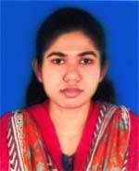 | DR. SAFINA AKHTER  F/Name: Md. Ruhul Amin  M/Name: Suraiya Ali  BM & DC Reg. No: 63280  NID: 19888524904189394  Cell: 01710044837  Address: Vill-Gotiasham, Post-Singerdabry hat, P.s-Rajarhat, Dist-Kurigram  Blood Group: A+
70 | Voter No  LM-3100070  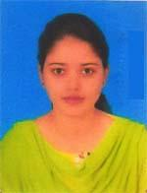 | DR. SAMPA SIKDER  F/Name: Nirmal Sikder  M/Name: Sapno Rani Sikder  BM & DC Reg. No: 76083  NID: 19915518511000240  Cell: 01747780246  Address: C/o Dr. Sidhartha Shanker Bose, Vill-Monar Kuti, Post-Nazim Khan, P.s-Rajarhat, Dist-Kurigram  Blood Group: A+
71 | Voter No  LM-3100071  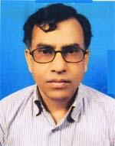 | DR. MD. MUSTAFIZUR RAHMAN  F/Name: Late Taslimuddin Sarker  M/Name: Mst. Morium Begum  BM & DC Reg. No: 16476  NID: 8524901009436  Cell: 01716437108  Address: Junior Consultant , Kurigram Sadar Hospital, Post+Dist-Kurigram  Blood Group: B+
72 | Voter No  LM-3100072  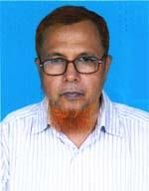 | DR. ABDUL HYE  F/Name: Late Moksed Ali Bepari  M/Name: Amena Bewa  BM & DC Reg. No: 13509  NID: 4925207133905  Cell: 01712524328  Address: Kurigram Sadar, Kurigram.  Blood Group: O+
73 | Voter No  LM-3100073  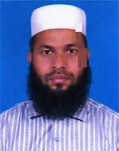 | DR. MD. HELAL MIAH  F/Name: Md. Azahar Ali  M/Name: Mst. Zobeda Khatun  BM & DC Reg. No: 36710  NID: 4925203109579  Cell: 01726863689  Address: Otobi, Busterminal, Kurigram  Blood Group: A+
74 | Voter No  LM-3100074  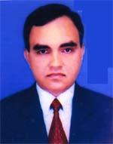 | DR. MD. HAFIZUR RAHMAN  F/Name: Late Harunar Rashid  M/Name: Mosammat Hasina Khatun  BM & DC Reg. No: 10055  NID: 8524901009644  Cell: 01716064135  Address: Hsania Manzil Paschim Bnageshwari,  Blood Group: O+
75 | Voter No  LM-3100075  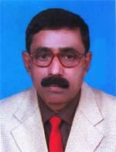 | DR. UPENDRA NATH SHIL  F/Name: Late Baidya Nath Shill  M/Name: Mrs. Pushpa Bala Shill  BM & DC Reg. No: 10968  NID: 4926104311520  Cell: 01712797091  Address: Vill-Pachim Nageswari, Post+Upazilla-Nageswari, Dist-Kurigram  Blood Group: O+  E X P I R E D
76 | Voter No  LM-3100076 | DR. BIVASH KUMER SHEEL  F/Name: Dr. Upardh Nath Shill  M/Name: Mrs. Kalpona Rani Sheel  BM & DC Reg. No: 51505  NID: 4820606426888  Cell: 01712235689  Address: Vill+Post+Upazilla-Nageswari, Dist-Kurigram  Blood Group: O+
77 | Voter No  LM-3100077  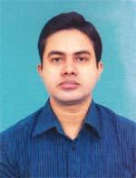 | DR. MD. SADEKUR RAHMAN  F/Name: Late Baser Uddin Ahmed  M/Name: Mrs. Rabeya Begum  BM & DC Reg. No: 51056  NID: 198524904043216  Cell: 01712694228  Address: Vill-Chandamary, Post-Rajarhat, Upazilla-Rajarhat, Dist-Kurigram  Blood Group: O+
78 | Voter No  LM-3100078  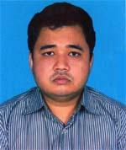 | DR. MD. MAINUL HASAN  F/Name: Dr. Md. Abdul Hye  M/Name: Monowara Begum  BM & DC Reg. No: 58543  NID: 4929406678901  Cell: 01714558230  Address: Vill-Poschim Munsipara, post-Kurigram Sadar, Dist-Kurigram  Blood Group: O+
79 | Voter No  LM-3100079  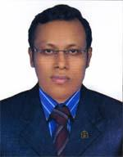 | DR. MD. ASHRAFUL ALAM  F/Name: Md. Abdul Mannan  M/Name: Most. Anowara Begum  BM & DC Reg. No: 53073  NID: 8198510364550  Cell: 01722833202  Address: Village-Polash bari, Post-Khalilgonj, Thana+Dist-Kurigram  Blood Group: AB+
80 | Voter No  LM-3100080  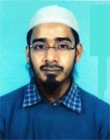 | DR. A. H. M. BORHAN UL ISLAM SIDDIKI  F/Name: Md. Abdul Malek  M/Name: Mst. Latifa Malek  BM & DC Reg. No: 40406  NID: 4910983524351  Cell: 01912934569  Address: I.M.O, Kurigram Sadar Hospital. Kurigram  Blood Group: A+
81 | Voter No  LM-3100081  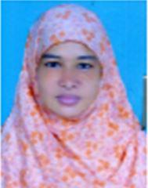 | DR. MOST UMMEKULSUM BEGUM  F/Name: Md. Fazlar Rahman  M/Name: Most. Jahanara Begum  BM & DC Reg. No: 39817  NID: 4915217191712  Cell: 01718078173  Address: District Hospital, Kurigram.  Blood Group: O+
82 | Voter No  LM-3100082 | DR. S. M. NURUL HUDA  F/Name: Sayed Md. Fazlul Haque  M/Name: Mst. Masuda Pervin  BM & DC Reg. No: 60583  NID: 8198510364777  Cell: 01717255979  Address: Vill-Paschim Naodanga, Post-Bakrerhat, P.s-Ulipur, Dist-Kurigram  Blood Group: O+
83 | Voter No  LM-3100083  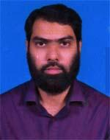 | DR. MD. AL AMIN MASUD  F/Name: Md. Quamrul Huda  M/Name: Mohsena Begum  BM & DC Reg. No: 44598  NID: 4925203112929  Cell: 01984298283  Address: District Sadar Hospital, Kurigram  Blood Group: A+
84 | Voter No  LM-3100084 | DR. SHUJAN CHANDRA BARMAN  F/Name: Late Dharani Kanta Barman  M/Name: Golapi Rani  BM & DC Reg. No: 36862  NID: 4919450671853  Cell: 01710589442  Address: House-49, Road-01, Guptapara, Rangpur  Blood Group: O+
85 | Voter No  LM-3100085  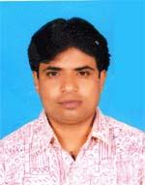 | DR. MD. AMZAD HOSSAIN  F/Name: Md. Abed Ali Munshi  M/Name: Most. Sabiron Begum  BM & DC Reg. No: 33203  NID: 4926106300435  Cell: 01716038394  Address: Indoor Medical officer, Surgery Rangpur Medical College Hospital  Blood Group: A+
86 | Voter No  LM-3100086 | DR. MD. RAFIQUL ISLAM SARDAR  F/Name: Md. Abul Hossain Sardar  M/Name: Mrs. Koresa Khatun  BM & DC Reg. No: 42592  NID: 1013367718832  Cell: 01712502280  Address: Doctors Quatar, UHC, Ulipur, Kurigram  Blood Group: B+
87 | Voter No  LM-3100087  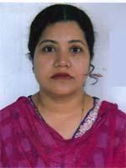 | DR. MAHABUBA KHATUN  F/Name: Late Mokbul Uddin Ahmed  M/Name: Mrs. Aftabun Nahar  BM & DC Reg. No: 27676  NID:  Cell: 01712687288  Address: Sno-Ho-Nir, Mia Para, Nazira, Kurigram  Blood Group: A+
88 | Voter No  LM-3100088  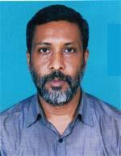 | DR. MD. AHSHANUL KABIR  F/Name: Md. Dianat Ali  M/Name: Jahanara Khatun  BM & DC Reg. No: 37675  NID: 19723616785309719  Cell: 01718020774  Address: Ana-Ho-Nir, Mia Para, Kurigram Sadar, Kurigram  Blood Group: AB+
89 | Voter No  LM-3100089  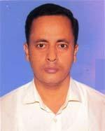 | DR. MD. ZAHANGIR ALAM  F/Name: Md. Akbar Ali  M/Name: Most Noorjahan Khatun  BM & DC Reg. No: 38487  NID: 4926104299912  Cell: 01712628229  Address: Unit-3, Doctors Quater Sadar Hospital, Kurigram  Blood Group: A+
90 | Voter No  LM-3100090  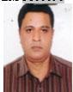 | DR. MD. SAIFUL HAQUE TALUKDER  F/Name: Late Abdul Haque Talukder  M/Name: Late Razia Shamsun Nahar  BM & DC Reg. No: A25622  NID: 261041393518  Cell: 01715327327  Address: Patand Thana, Kurigran.  Blood Group: A+
91 | Voter No  LM-3100091  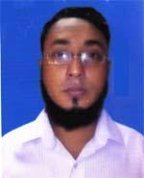 | DR. MD. ARIFUL ISLAM  F/Name: Md. Ashraf Ali  M/Name: Late Monira Ali  BM & DC Reg. No: 64407  NID: 19812696536026925  Cell: 01719402243  Address: R.K Road Khaligonj, Kurigram  Blood Group: A+

